FY 2015 TEMPLATE
Environmental Collaboration and Conflict Resolution (ECCR)
Policy Report to OMB-CEQ
On September 7, 2012, the Director of the Office of Management and Budget (OMB), and the Chairman of the President's Council on Environmental Quality (CEQ) issued a revised policy memorandum on environmental collaboration and conflict resolution (ECCR). This joint memo builds on, reinforces, and replaces the memo on ECR issued in 2005.
The memorandum requires annual reporting by departments and agencies to OMB and CEQ on progress made each year in implementing the ECCR policy direction to increase the effective use and institutional capacity for ECCR.
ECCR is defined in Section 2 of the 2012 memorandum as:
“. . . third-party assisted collaborative problem solving and conflict resolution in the context of environmental, public lands, or natural resources issues or conflicts, including matters related to energy, transportation, and water and land management.
The term Environmental Collaboration and Conflict Resolution encompasses a range of assisted collaboration, negotiation, and facilitated dialogue processes and applications. These processes directly engage affected interests and Federal department and agency decision makers in collaborative problem solving and conflict resolution.
Multi-issue, multi-party environmental disputes or controversies often take place in high conflict and low trust settings, where the assistance of impartial facilitators or mediators can be instrumental to reaching agreement and resolution. Such disputes range broadly from policy and regulatory disputes to administrative adjudicatory disputes, civil judicial disputes, intra- and interagency disputes, and disputes with non-Federal persons and entities.
Environmental Collaboration and Conflict Resolution can be applied during policy development or planning in the context of a rulemaking, administrative decision making, enforcement, or litigation with appropriate attention to the particular requirements of those processes. These contexts typically involve situations where a Federal department or agency has ultimate responsibility for decision making and there may be disagreement or conflict among Federal, Tribal, State and local governments and agencies, public interest organizations, citizens groups, and business and industry groups.
Although Environmental Collaboration and Conflict Resolution refers specifically to collaborative and conflict resolution processes aided by third-party neutrals, there is a broad array of partnerships, cooperative arrangements, and unassisted negotiations that Federal agencies may pursue with non-Federal entities to plan, manage, and implement department and agency programs and activities. The Basic Principles for Agency Engagement in Environmental Conflict Resolution and Collaborative Problem Solving are presented in Attachment B. The Basic Principles provide guidance that applies to both Environmental Collaboration and Conflict Resolution and unassisted collaborative problem solving and conflict resolution. This policy recognizes the importance and value of the appropriate use of all forms collaborative problem solving and conflict resolution.”
This annual report format below is provided for the seventh year of reporting in accordance with the memo for activities in FY 2015.
The report deadline is February 15, 2016.
We understand that collecting this information may be challenging; however, the departments and agencies are requested to collect this data to the best of their abilities. The 2015 report, along with previous reports, will establish a useful baseline for your department or agency, and collect some information that can be aggregated across agencies. Departments should submit a single report that includes ECCR information from the agencies and other entities within the department. The information in your report will become part of an analysis of all FY 2015 ECCR reports. You may be contacted for the purpose of clarifying information in your report. For your reference, prior year synthesis reports are available at http://www.ecr.gov/Resources/FederalECRPolicy/AnnualECRReport.aspx
FY 13 ECCR Report Template
Name of Department/Agency responding: | ________________________
Name and Title/Position of person responding: | ________________________
Division/Office of person responding: | ________________________
Contact information (phone/email): | ________________________
Date this report is being submitted:  Name of ECR Forum Representative | ________________________  ________________________

- ECCR Capacity Building Progress: Describe steps taken by your department or agency to build programmatic and institutional capacity for environmental collaboration and conflict resolution in FY 2015, including progress made since FY 2012. Include any efforts to establish routine procedures for considering ECCR in specific situations or categories of cases. To the extent your organization wishes to report on any efforts to provide institutional support for non-assisted collaboration efforts include it here. If no steps were taken, please indicate why not.
[Please refer to the mechanisms and strategies presented in Section 5 and attachment C of the OMB-CEQ ECCR Policy Memo, including but not restricted to any efforts to a) integrate ECCR objectives into agency mission statements, Government Performance and Results Act goals, and strategic planning; b) assure that your agency’s infrastructure supports ECCR; c) invest in support, programs, or trainings; and d) focus on accountable performance and achievement. You are encouraged to attach policy statements, plans and other relevant documents.]

- ECCR Investments and Benefits
  - Please describe any methods your agency uses to identify the (a) investments made in ECCR, and (b) benefits realized when using ECCR.
Examples of investments may include ECCR programmatic FTEs, dedicated ECCR budgets, funds spent on contracts to support ECCR cases and programs, etc.
Examples of benefits may include cost savings, environmental and natural resource results, furtherance of agency mission, improved working relationship with stakeholders, litigation avoided, timely project progression, etc.
  - Please report any (a) quantitative or qualitative investments your agency captured during FY 2015; and (b) quantitative or qualitative results (benefits) you have captured during FY 2015.
  - What difficulties have you encountered in generating cost and benefit information and how do you plan to address them?

- ECCR Use: Describe the level of ECCR use within your department/agency in FY 2015 by completing the table below. [Please refer to the definition of ECCR from the OMB-CEQ memo as presented on page one of this template. An ECCR “case or project” is an instance of neutral third-party involvement to assist parties in a collaborative or conflict resolution process. In order not to double count processes, please select one category per case for decision making forums and for ECCR applications.

 | Total  FY 2015  ECCR Cases | Decision making forum that was addressing the issues when ECCR was initiated: |  |  |  |  | ECCR Cases or projects completed | ECCR Cases or Projects sponsored | Interagency  ECCR Cases and Projects
 | Total  FY 2015  ECCR Cases | Federal agency decision | Administrative proceedings /appeals | Judicial proceedings | Other (specify) |  | ECCR Cases or projects completed | ECCR Cases or Projects sponsored | Federal  only | Including non federal participants
Context for ECCR Applications:
Policy development | _____ | _____ | _____ | _____ | _____ |  | _____ | _____ | _____ | _____
Planning | _____ | _____ | _____ | _____ | _____ |  | _____ | _____ | _____ | _____
Siting and construction | _____ | _____ | _____ | _____ | _____ |  | _____ | _____ | _____ | _____
Rulemaking | _____ | _____ | _____ | _____ | _____ |  | _____ | _____ | _____ | _____
License and permit issuance | _____ | _____ | _____ | _____ | _____ |  | _____ | _____ | _____ | _____
Compliance and enforcement action | _____ | _____ | _____ | _____ | _____ |  | _____ | _____ | _____ | _____
Implementation/monitoring agreements | _____ | _____ | _____ | _____ | _____ |  | _____ | _____ | _____ | _____
Other (specify): __________________ | _____ | _____ | _____ | _____ | _____ |  | _____ | _____ | _____ | _____
TOTAL | _____ | _____ | _____ | _____ | _____ |  | _____ | _____ | _____ | _____
TOTAL |  | (the sum of the Decision Making Forums  should equal Total FY 2015 ECCR Cases)

4. ECCR Case Example

Using the template below, provide a description of an ECCR case (preferably completed in FY 2015). Please limit the length to no more than 2 pages.

Name/Identification of Problem/Conflict
Overview of problem/conflict and timeline, including reference to the nature and timing of the third-party assistance, and how the ECCR effort was funded
Summary of how the problem or conflict was addressed using ECCR, including details of any innovative approaches to ECCR, and how the principles for engagement in ECCR outlined in the policy memo were used
Identify the key beneficial outcomes of this case, including references to likely alternative decision making forums and how the outcomes differed as a result of ECCR
Reflections on the lessons learned from the use of ECCR

5. Other ECCR Notable Cases: Briefly describe any other notable ECCR cases in the past fiscal year. (Optional)

6. Priority Uses of ECCR:

Please describe your agency’s efforts to address priority or emerging areas of conflict and cross-cutting challenges either individually or in coordination with other agencies. For example, consider the following areas: NEPA, ESA, CERCLA, energy development, energy transmission, CWA 404 permitting, tribal consultation, environmental justice, management of ocean resources, infrastructure development, National Historic Preservation Act, other priority areas.

7. Non-Third-Party-assisted Collaboration Processes: Briefly describe other significant uses of environmental collaboration that your agency has undertaken in FY 2015 to anticipate, prevent, better manage, or resolve environmental issues and conflicts that do not include a third-party neutral. Examples may include interagency MOUs, enhanced public engagement, and structural committees with the capacity to resolve disputes, etc.

8. Comments and Suggestions re: Reporting: Please comment on any difficulties you encountered in collecting these data and if and how you overcame them. Please provide suggestions for improving these questions in the future.

Please attach any additional information as warranted.

Report due February 15, 2016.
Submit report electronically to: ECRReports@omb.eop.gov

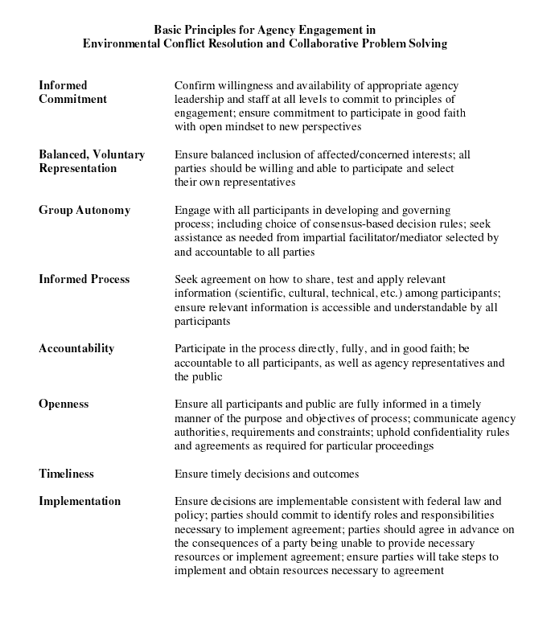

The term ‘ECCR’ includes third-party neutral assistance in environmental collaboration and environmental conflict resolution
An “ECCR case” is a case in which a third-party neutral was active in a particular matter during FY 2015.
A “completed case” means that neutral third party involvement in a particular ECCR case ended during FY 2015. The end of neutral third party involvement does not necessarily mean that the parties have concluded their collaboration/negotiation/dispute resolution process, that all issues are resolved, or that agreement has been reached.
Sponsored - to be a sponsor of an ECCR case means that an agency is contributing financial or in-kind resources (e.g., a staff mediator's time) to provide the neutral third party's services for that case. More than one sponsor is possible for a given ECCR case. Note: If you subtract completed ECCR cases from Total FY 2015 cases it should equal total ongoing cases. If you subtract sponsored ECCR cases from Total FY 2015 ECCR cases it should equal total cases in which your agency or department participated but did not sponsor. If you subtract the combined interagency ECCR cases from Total FY 2015 cases it should equal total cases that involved only your agency or department with no other federal agency involvement.

