FY 2020 TEMPLATE
Environmental Collaboration and Conflict Resolution (ECCR)
Policy Report to OMB-CEQ
On September 7, 2012, the Director of the Office of Management and Budget (OMB), and the Chairman of the President's Council on Environmental Quality (CEQ) issued a revised policy memorandum on environmental collaboration and conflict resolution (ECCR). This joint memo builds on, reinforces, and replaces the memo on ECR issued in 2005.
The memorandum requires annual reporting by departments and agencies to OMB and CEQ on progress made each year in implementing the ECCR policy direction to increase the effective use and institutional capacity for ECCR.
ECCR is defined in Section 2 of the 2012 memorandum as:
“. . . third-party assisted collaborative problem solving and conflict resolution in the context of environmental, public lands, or natural resources issues or conflicts, including matters related to energy, transportation, and water and land management.
The term Environmental Collaboration and Conflict Resolution encompasses a range of assisted collaboration, negotiation, and facilitated dialogue processes and applications. These processes directly engage affected interests and Federal department and agency decision makers in collaborative problem solving and conflict resolution.
Multi-issue, multi-party environmental disputes or controversies often take place in high conflict and low trust settings, where the assistance of impartial facilitators or mediators can be instrumental to reaching agreement and resolution. Such disputes range broadly from policy and regulatory disputes to administrative adjudicatory disputes, civil judicial disputes, intra- and interagency disputes, and disputes with non-Federal persons and entities.
Environmental Collaboration and Conflict Resolution can be applied during policy development or planning in the context of a rulemaking, administrative decision making, enforcement, or litigation with appropriate attention to the particular requirements of those processes. These contexts typically involve situations where a Federal department or agency has ultimate responsibility for decision making and there may be disagreement or conflict among Federal, Tribal, State and local governments and agencies, public interest organizations, citizens groups, and business and industry groups.
Although Environmental Collaboration and Conflict Resolution refers specifically to collaborative and conflict resolution processes aided by third-party neutrals, there is a broad array of partnerships, cooperative arrangements, and unassisted negotiations that Federal agencies may pursue with non-Federal entities to plan, manage, and implement department and agency programs and activities. The Basic Principles for Agency Engagement in Environmental Conflict Resolution and Collaborative Problem Solving are presented in Attachment B. The Basic Principles provide guidance that applies to both Environmental Collaboration and Conflict Resolution and unassisted collaborative problem solving and conflict resolution. This policy recognizes the importance and value of the appropriate use of all forms collaborative problem solving and conflict resolution.”
This annual reporting template is provided in accordance with the memo for activities in FY 2020.
The report deadline is February 26, 2021.
We understand that collecting this information may be challenging; however, the departments and agencies are requested to collect this data to the best of their abilities. The FY 2020 report, along with previous reports, will establish a useful baseline for your department or agency. Departments should submit a single report that includes ECCR information from the agencies and other entities within the department. The information in your report will become part of an analysis of all FY 2020 ECCR reports. You may be contacted for the purpose of clarifying information in your report.
For your reference, synthesis reports from past fiscal years are available at https://www.udall.gov/OurPrograms/Institute/ECRReport.aspx.
FY 2020 ECCR Report Template
Name of Department/Agency responding:
Name and Title/Position of person responding:
Division/Office of person responding:
Contact information (phone/email):
Date this report is being submitted:

Name of ECCR Forum Representative
1. ECCR Capacity Building Progress:
  - Describe any NEW, CHANGED, or ACTIVELY ONGOING steps taken by your department or agency to build programmatic and institutional capacity for environmental collaboration and conflict resolution in FY 2020, including progress made since FY 2019.
Please also include any efforts to establish routine procedures for considering ECCR in specific situations or categories of cases, including any efforts to provide institutional support for non-assisted collaboration efforts.
Please refer to the mechanisms and strategies presented in Section 5 and attachment C of the OMB-CEQ ECCR Policy Memo for additional guidance on what to include here. Examples include but are not restricted to efforts to:
- Integrate ECCR objectives into agency mission statements, Government Performance and Results Act goals, and strategic planning;
- Assure that your agency’s infrastructure supports ECCR;
- Invest in support, programs, or trainings; and d) focus on accountable performance and achievement.
Please refer to your agency’s FY 2019 report to only include new, changed or actively ongoing ECCR capacity building progress. If none, leave this section blank.

  - Please describe the trainings given in your department/agency in FY 2020. Please include a list of the trainings, if possible. If known, please provide the course names and total number of people trained. Please refer to your agency’s FY 2019 report to include ONLY trainings given in FY 2020. If none, leave this section blank.

2. ECCR Investments and Benefits
  - Please describe any NEW or CHANGED or INNOVATIVE investments made in ECCR in FY 2020. Examples of investments may include (but are not limited to):
- ECCR programmatic FTEs
- Dedicated ECCR budgets
- Funds spent on contracts to support ECCR cases and programs
Please refer to your agency’s FY 2019 report to only include new, changed, or innovative investments made in ECCR. If none, leave this section blank.

  - Please describe any NEW or CHANGED benefits realized when using ECCR in FY 2020. Examples of benefits may include (but are not limited to):
- Cost savings
- Environmental and natural resource results
- Furtherance of agency mission
- Improved working relationship with stakeholders
- Avoidance of litigation
- Timely project progression
Please refer to your agency’s FY 2019 report to only include new or changed benefits of ECCR realized in FY 2020. If none, leave this section blank.

- ECCR Use
Describe the level of ECCR use within your department/agency in FY 2020 by completing the three tables below. [Please refer to the definition of ECCR from the OMB-CEQ memo as presented on page one of this template. An ECCR “case or project” is an instance of neutral third-party involvement to assist parties in a collaborative or conflict resolution process.]
To avoid double counting processes, please select one category per case for decision making forums and for ECCR applications.
Context for ECCR Applications: | Total  FY 2020  ECCR Cases | Decision making forum that was addressing the issues when ECCR was initiated:
Context for ECCR Applications: | Total  FY 2020  ECCR Cases | Federal agency decision | Administrative proceedings /appeals | Judicial proceedings | Other** (specify below)
Policy development | _____ | _____ | _____ | _____ | _____
Planning | _____ | _____ | _____ | _____ | _____
Siting and construction | _____ | _____ | _____ | _____ | _____
Rulemaking | _____ | _____ | _____ | _____ | _____
License and permit issuance | _____ | _____ | _____ | _____ | _____
Compliance and enforcement action | _____ | _____ | _____ | _____ | _____
Implementation/monitoring agreements | _____ | _____ | _____ | _____ | _____
Other (specify): __________________ | _____ | _____ | _____ | _____ | _____
TOTAL | _ ________ | _____ | _____ | _____ | _____
TOTAL |  | (the sum of the Decision Making Forums  should equal Total FY 2020 ECCR Cases)

**If you indicated above that any of your ECCR cases or projects were initiated in an “other” decision making forum, please elaborate here.

Context for ECCR Applications: | Interagency  ECCR Cases and Projects
Context for ECCR Applications: | Included Other Federal Agencies Only | Included Non-Federal Participants (e.g., states, Tribes, and non governmental)
Policy development | _____ | _____
Planning | _____ | _____
Siting and construction | _____ | _____
Rulemaking | _____ | _____
License and permit issuance | _____ | _____
Compliance and enforcement action | _____ | _____
Implementation/monitoring agreements | _____ | _____
Other (specify): __________________ | _____ | _____
TOTAL | _____ | _____

Context for ECCR Applications: | ECCR Cases or projects completed | ECCR Cases or Projects sponsored
Policy development | _____ | _____
Planning | _____ | _____
Siting and construction | _____ | _____
Rulemaking | _____ | _____
License and permit issuance | _____ | _____
Compliance and enforcement action | _____ | _____
Implementation/monitoring agreements | _____ | _____
Other (specify): __________________ | _____ | _____
TOTAL | __________ | _____

4. ECCR Case Example
Using the template below, provide a description of an ECCR case (preferably completed in FY 2020). If possible, focus on an interagency ECCR case. Please limit the length to no more than 1 page.

Name/Identification of Problem/Conflict:
[Please add case “title” here]
Overview of problem/conflict and timeline, including reference to the nature and timing of the third-party assistance, and how the ECCR effort was funded.
Summary of how the problem or conflict was addressed using ECCR, including details of any innovative approaches to ECCR, and how the principles for engagement in ECCR outlined in the policy memo were used.
Identify the key beneficial outcomes of this case, including references to likely alternative decision-making forums and how the outcomes differed as a result of ECCR.
Please share any reflections on the lessons learned from the use of ECCR.

5. Other ECCR Notable Cases
Briefly describe any other notable ECCR cases in FY 2020. (OPTIONAL)

6. Priority Uses of ECCR
Please describe your agency’s NEW or CHANGED efforts to address priority or emerging areas of conflict and cross-cutting challenges either individually or in coordination with other agencies. For example, consider the following areas: NEPA, ESA, CERCLA, energy development, energy transmission, CWA 404 permitting, tribal consultation, environmental justice, management of ocean resources, infrastructure development, National Historic Preservation Act, other priority areas. Please refer to your agency’s FY 2019 report to only include new or increased priority uses. If none, leave this section blank.

7. Non-Third Party-Assisted Collaboration Processes (Optional)
Briefly describe other significant uses of environmental collaboration that your agency has undertaken in FY 2020 to anticipate, prevent, better manage, or resolve environmental issues and conflicts that do not include a third-party neutral. Examples may include interagency MOUs, enhanced public engagement, and structural committees with the capacity to resolve disputes, etc. If none, leave this section blank.

8. Comments and Suggestions on Reporting
Please comment on any NEW or CHANGED difficulties you encountered in collecting these data and if and how you overcame them. Please provide suggestions for improving these questions in the future. Please reference your agency’s FY 2019 report to identify new/increased difficulties. If none, leave this section blank.

Please attach any additional information as warranted.

Report due Friday, February 26, 2020.
Submit report electronically to: kavanaugh@udall.gov

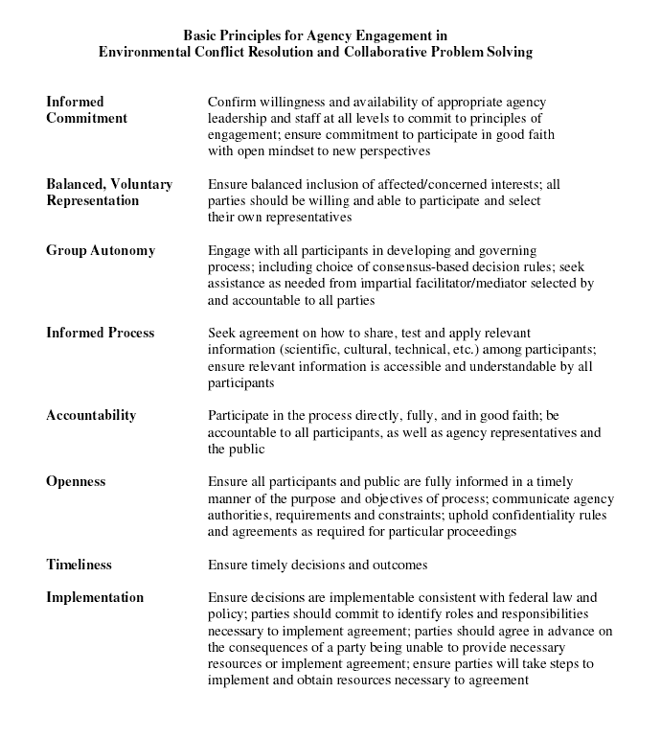

The term ‘ECCR’ includes third-party neutral assistance in environmental collaboration and environmental conflict resolution
An “ECCR case” is a case in which a third-party neutral was active in a particular matter during FY 2020.
A “completed case” means that neutral third-party involvement in a particular ECCR case ended during FY 2020. The end of neutral third-party involvement does not necessarily mean that the parties have concluded their collaboration/negotiation/dispute resolution process, that all issues are resolved, or that agreement has been reached.
Sponsored - to be a sponsor of an ECCR case means that an agency is contributing financial or in-kind resources (e.g., a staff mediator's time) to provide the neutral third party's services for that case. More than one sponsor is possible for a given ECCR case. Note: If you subtract completed ECCR cases from Total FY 2020 cases it should equal total ongoing cases. If you subtract sponsored ECCR cases from Total FY 2020 ECCR cases it should equal total cases in which your agency or department participated but did not sponsor. If you subtract the combined interagency ECCR cases from Total FY 2020 cases it should equal total cases that involved only your agency or department with no other federal agency involvement.

